Molecular Reactions

Proposed play area:

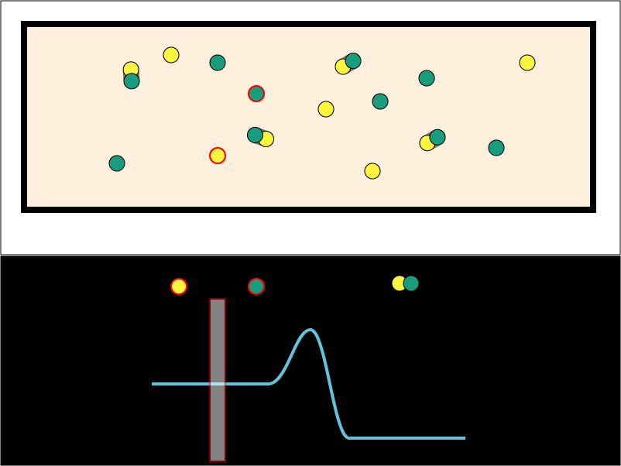

The upper half is shows green and yellow molecules bouncing around in a box. If one of each type hit each other with sufficient energy, they form a new, combined molecule that has the proper combined linear and angular momentum.
The use will be able to select a single molecule in the upper part of the play area to track in the lower half of the play area. The selected molecule is highlighted with a red border so the user can track it visually. The molecule of the other type nearest to the selected molecule is automatically highlighted.
The lower half of the play area shows a representation of the potential energy of a single molecule in the upper area. The curve shows the potential energy of a single molecule as it gets closer to single molecules of the other type, and as it collides and merges with them. The vertical bar is a cursor that moves left and right as the distance changes between the user-selected molecule and the closest molecule of the other type. The molecule representations near the top of the black area are icons the represent the collision/reaction state of the selected molecule.
The user will be able to manipulate the potential surface with the mouse. The peak of the curve will be movable up and down, as will the level parts of the surface to the left and right of the curve.

Suggestions
The user should be able to slow the simulation clock rate so that reactions are easier to see proceed.

Questions
What causes a combined molecule to dissociate?

